Breakout Session 1

Building a dashboard exercise

*This is the final look of dashboard once you’ve completed this exercise (or close to it)*

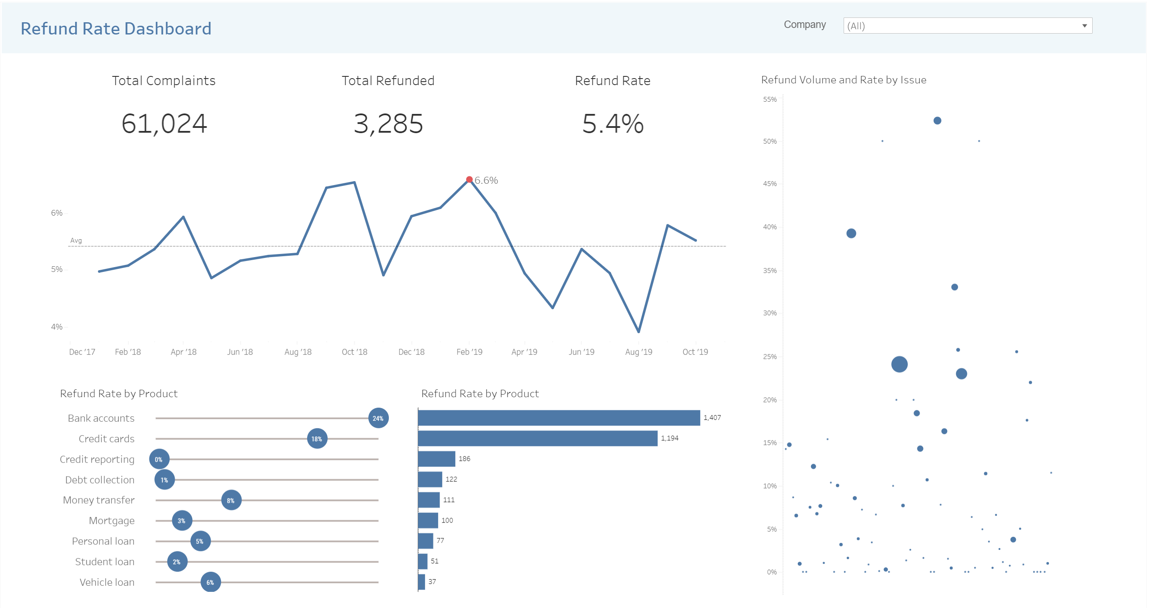

1. Visit Tableau Public and download the software to your computer
   1. Create a Tableau Public profile as you will need it to publish your work online
2. Download the California Complaints sample data from my Google Drive
   1. Link: <https://docs.google.com/spreadsheets/d/1CngEUp6nd4tA8SOUAbJg59vLvj0Y4sMsp7jCv2diNy0/edit?usp=sharing>
3. File 🡪 Download 🡪 comma-separated values
4. Save the file to your local computer
5. Open Tableau Public on your computer
6. Connect to file 🡪 text file 🡪 select complaint data file

*You should see something similar to this on your Data Source tab*

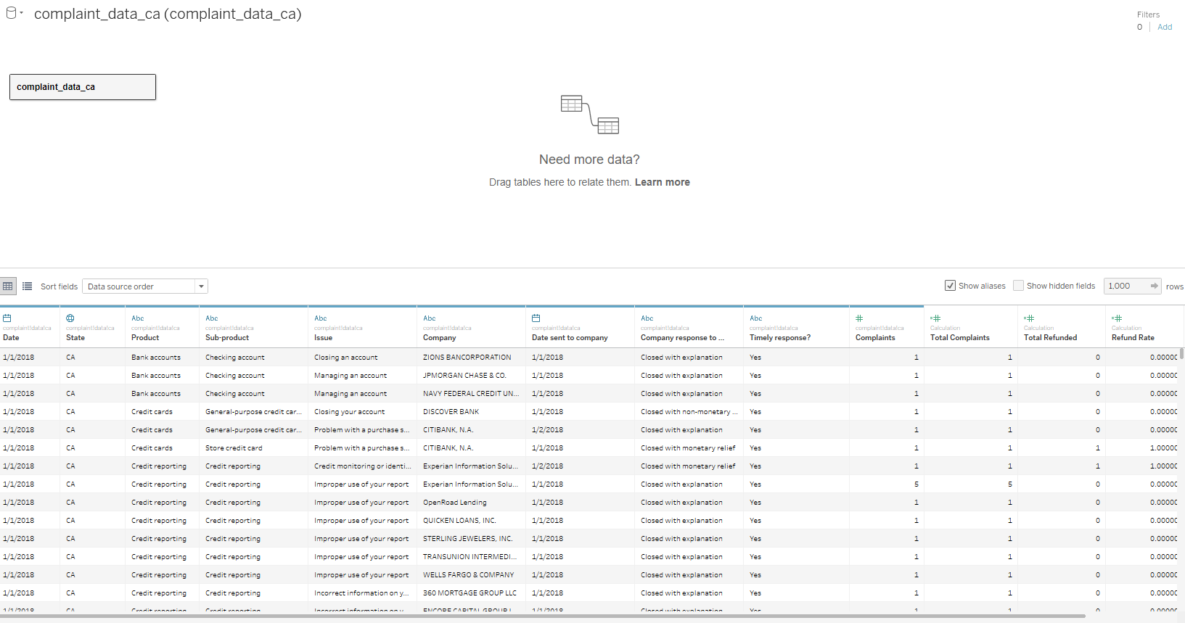

1. Review data source tab
   1. Data types
      1. Number
      2. Dates
      3. Strings
      4. Boolean
   2. Rename values
      1. **Change Complaint ID to Complaints 🡪 Scroll right to Complaint ID at end of data table in Data Source 🡪 Right click and rename Complaints**
2. Click Sheet 1 to view Worksheet

*Your blank worksheet will look like image below. Next, we will create the measures highlighted below*

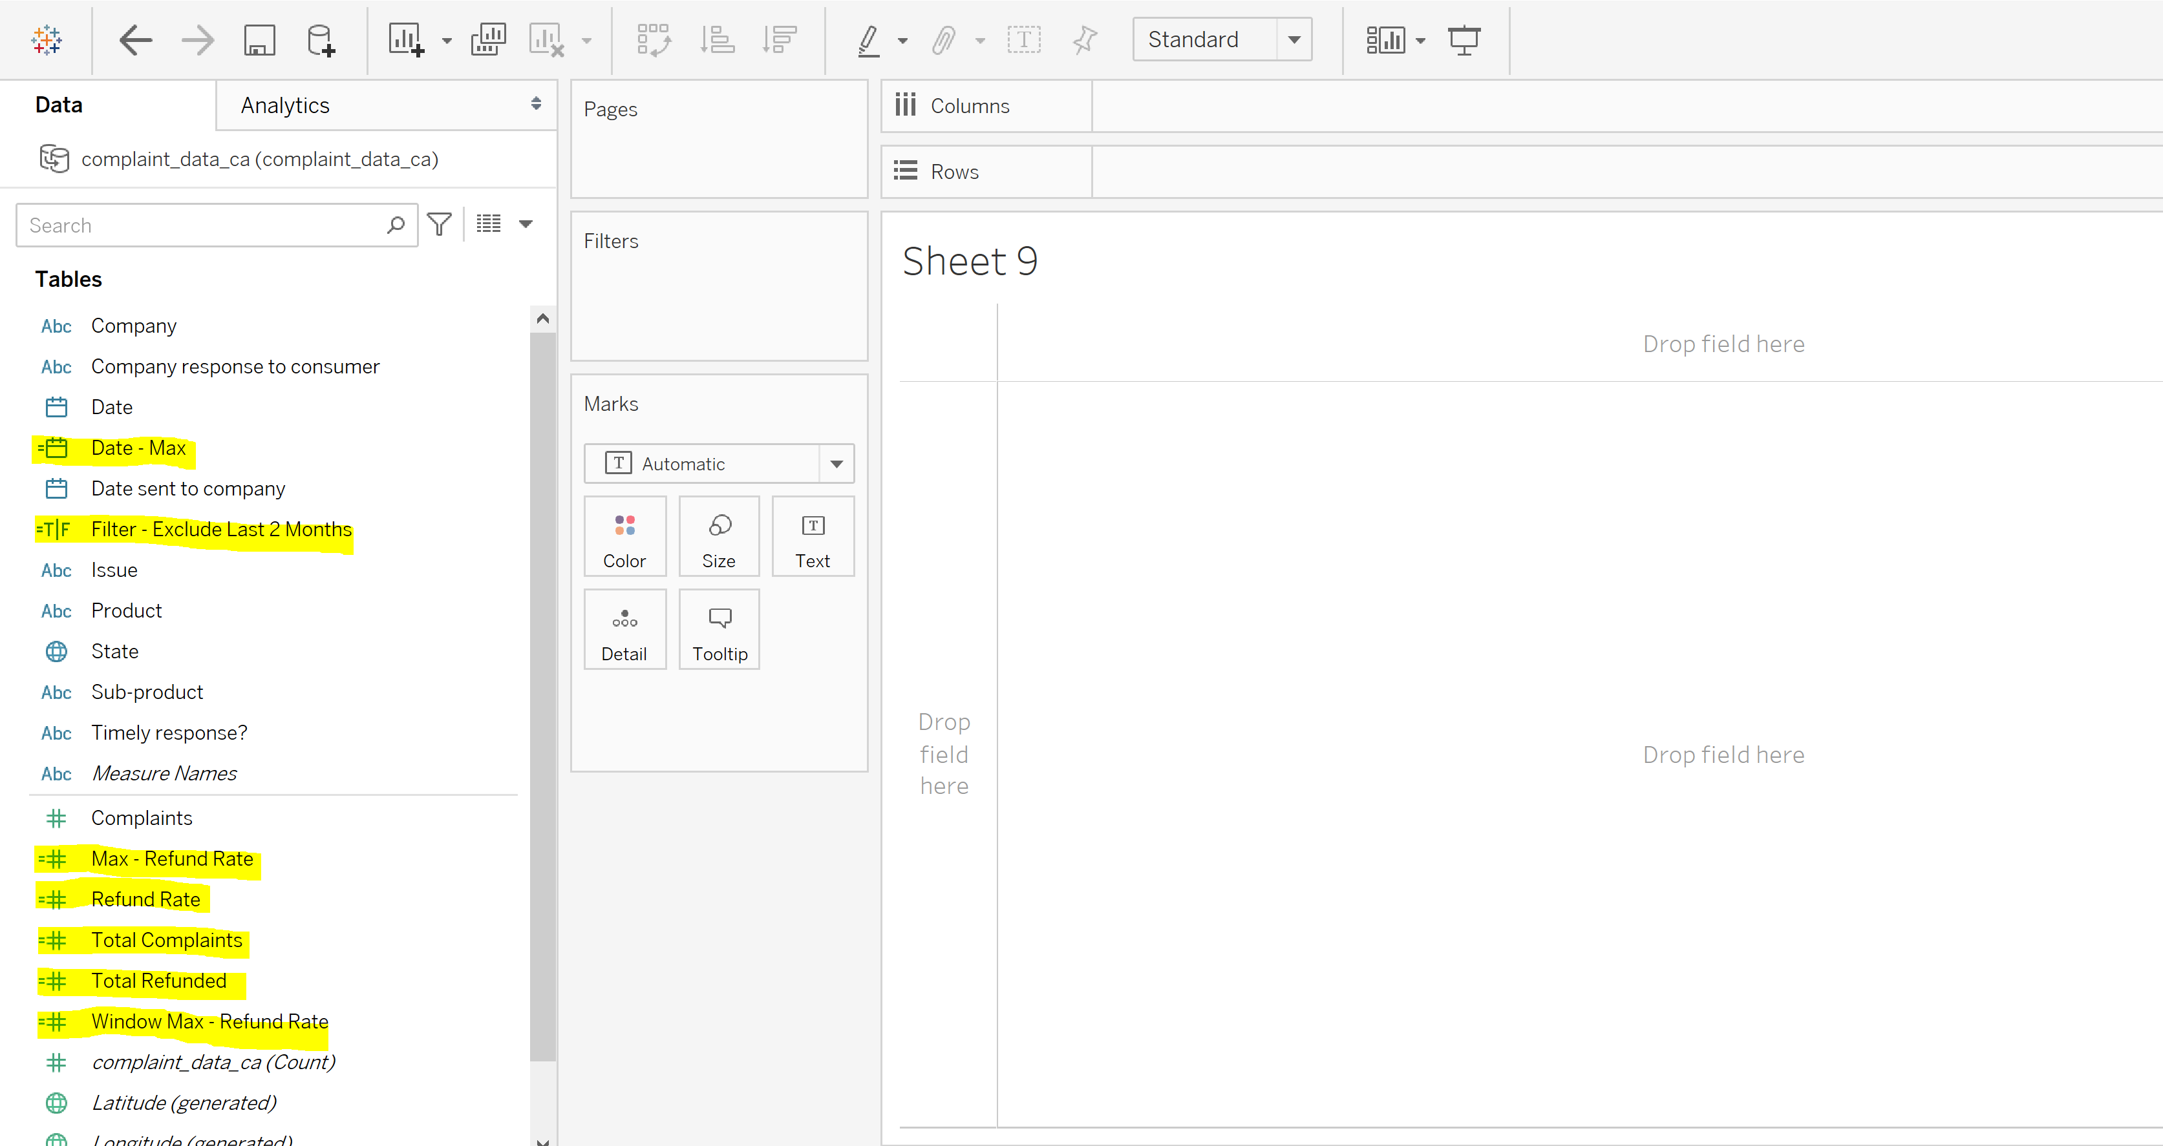

When creating calculated measures, you will interact with dialog boxes. Measure name goes in top left and formula is written in the view area.

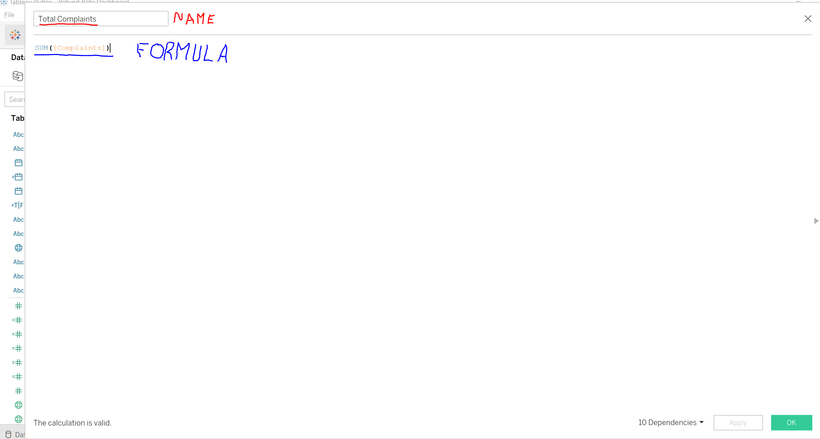

1. Creating measures
   1. Create your first measure
      1. Analysis menu 🡪 Create Calculated Field
      2. Create this list of 7 measures
         1. Total Complaints
            1. Change calculated field name to Total Complaints
            2. Formula: SUM([Complaints])
         2. Total Refunds
            1. Change calculated field name to Total Refunds
            2. Formula: SUM(IF [Company response to consumer] = 'Closed with monetary relief' THEN [Complaints] ELSE 0 END)
         3. Refund Rate
            1. Change calculated field name to Refunded Rate
            2. Formula: [Total Refunds]/[Total Complaints]
         4. Max – Refund Rate
            1. Change calculated field name to Max – Refund Rate
            2. Formula: IF [Refund Rate] = WINDOW_MAX([Refund Rate]) THEN [Refund Rate] ELSE NULL END
         5. Date – Max
            1. Change calculated field name to Date – Max
            2. Formula = {FIXED: MAX([Date])}
         6. Filter - Exclude Last 2 Months
            1. Change calculated field name to Filter - Exclude Last 2 Months
            2. Formula: [Date] <= DATEADD('month', -2, [Date - Max])
         7. Window Max – Refund Rate
            1. Change calculated field name to Window Max – Refund Rate
            2. Formula: WINDOW_MAX([Refund Rate])
2. Creating visualizations

*You will now add filters to the worksheet which will be used on all worksheets using the data source*

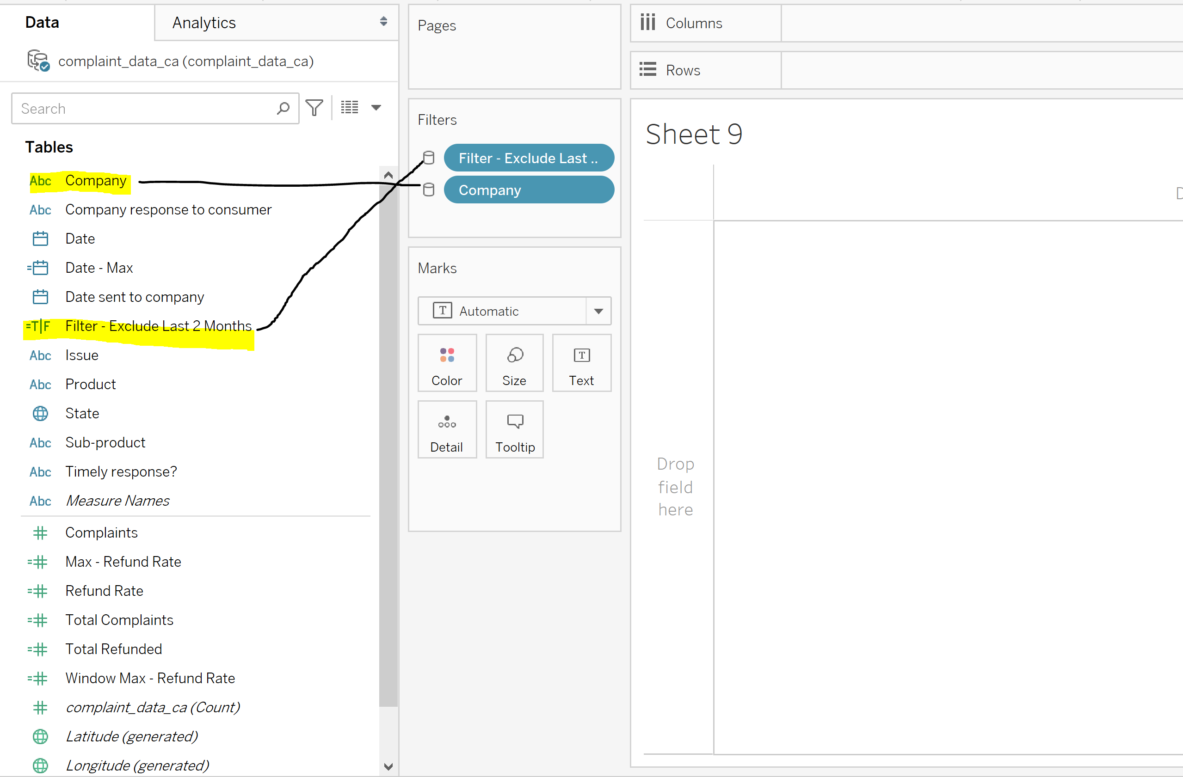

* 1. Filtering worksheets
     1. Drag Filter - Exclude Last 2 Months into Filters card 🡪 Select True 🡪 OK 🡪 Right dropdown arrow in Filter pill 🡪 Apply to Worksheets 🡪 All Using This Data Source
     2. Drag the Company dimension into the Filters card 🡪 OK 🡪 Right dropdown arrow in Filter pill 🡪 Apply to Worksheets 🡪 All Using This Data Source

*A bang box visual is nothing more than a large KPI that directs audience to most important numbers*

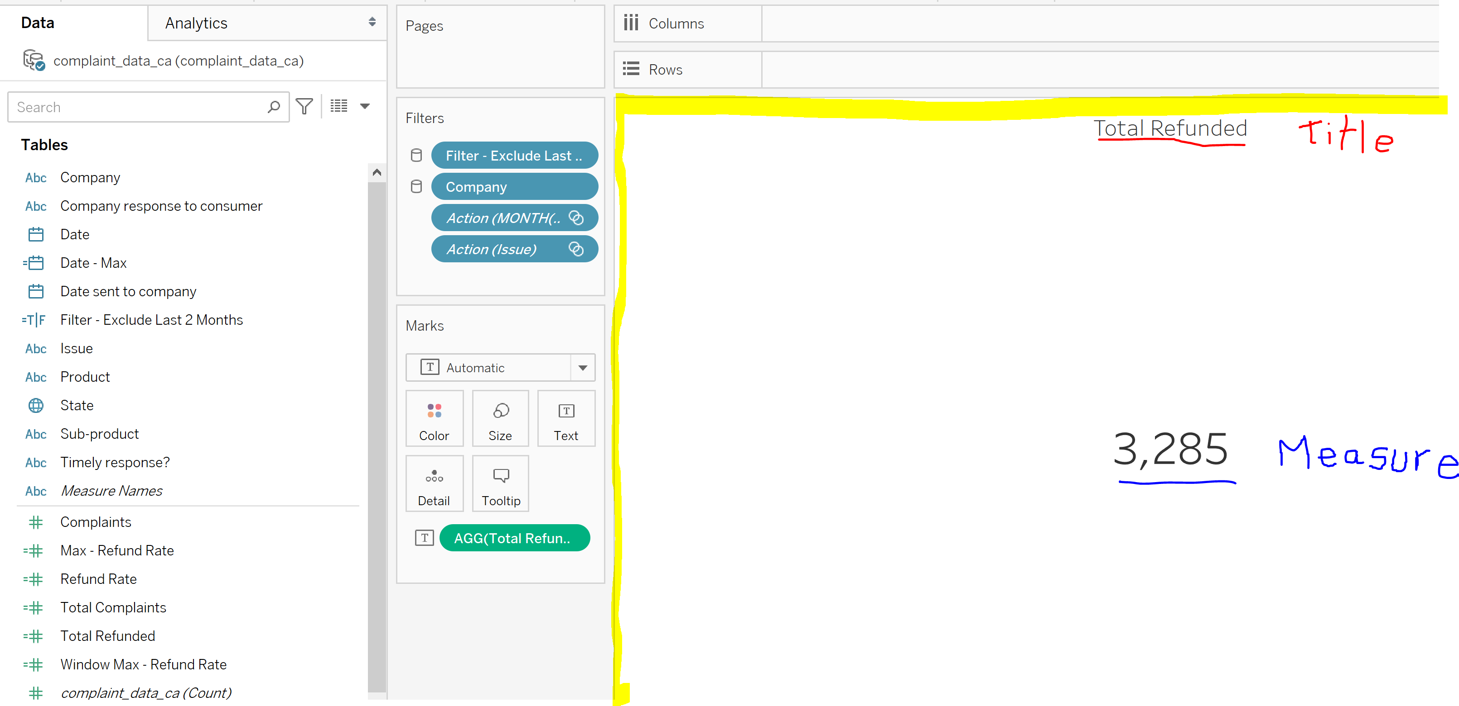

* 1. Creating Bang Boxes
     1. Total Complaints Bang Box
        1. Right click on the Sheet 1 tab 🡪 Rename to Total Complaints Bang Box
        2. Drag Total Complaints into the View area
        3. Click view dropdown in Standard toolbar at top 🡪 Select Entire View
        4. Click in whitespace in bang box area 🡪 Format 🡪 Click alignment in the Format section to the right 🡪 Click Pane dropdown in Default section 🡪 Center 🡪 Click Format Text 🡪 Sheet tab 🡪 Update font size to 24
        5. Right click the title on top of the view 🡪 Delete text 🡪 Type Total Complaints 🡪 Change font to 12 in font size dropdown 🡪 Click center alignment in top of dialog box 🡪 OK
     2. Total Refunds Bang Box
        1. Right click the Total Complaints Bang Box tab at bottom of Workspace pane 🡪 Select Duplicate 🡪 Right click duplicated tab 🡪 Rename 🡪 Type Total Refunds Bang Box
        2. Drag Total Refunds on top of the Total Complaints measure in the Marks card to swap measures
        3. Right click the title on top of the view 🡪 Delete text 🡪 Type Total Refunds 🡪 OK
     3. Refund Rate Bang Box
        1. Right click the Total Complaints Bang Box tab at bottom of Workspace pane 🡪 Select Duplicate 🡪 Right click duplicated tab 🡪 Rename 🡪 Type Refund Rate Bang Box
        2. Drag Refund Rate on top of the Total Complaints measure in the Marks card to swap measures
        3. Right click the Refund Rate measure 🡪 Format 🡪 Numbers in Default section 🡪 Percentage 🡪 1 decimal place
        4. Right click the title on top of the view 🡪 Delete text 🡪 Type Refund Rate 🡪 OK

*When bang box is complete it should look similar to image below*

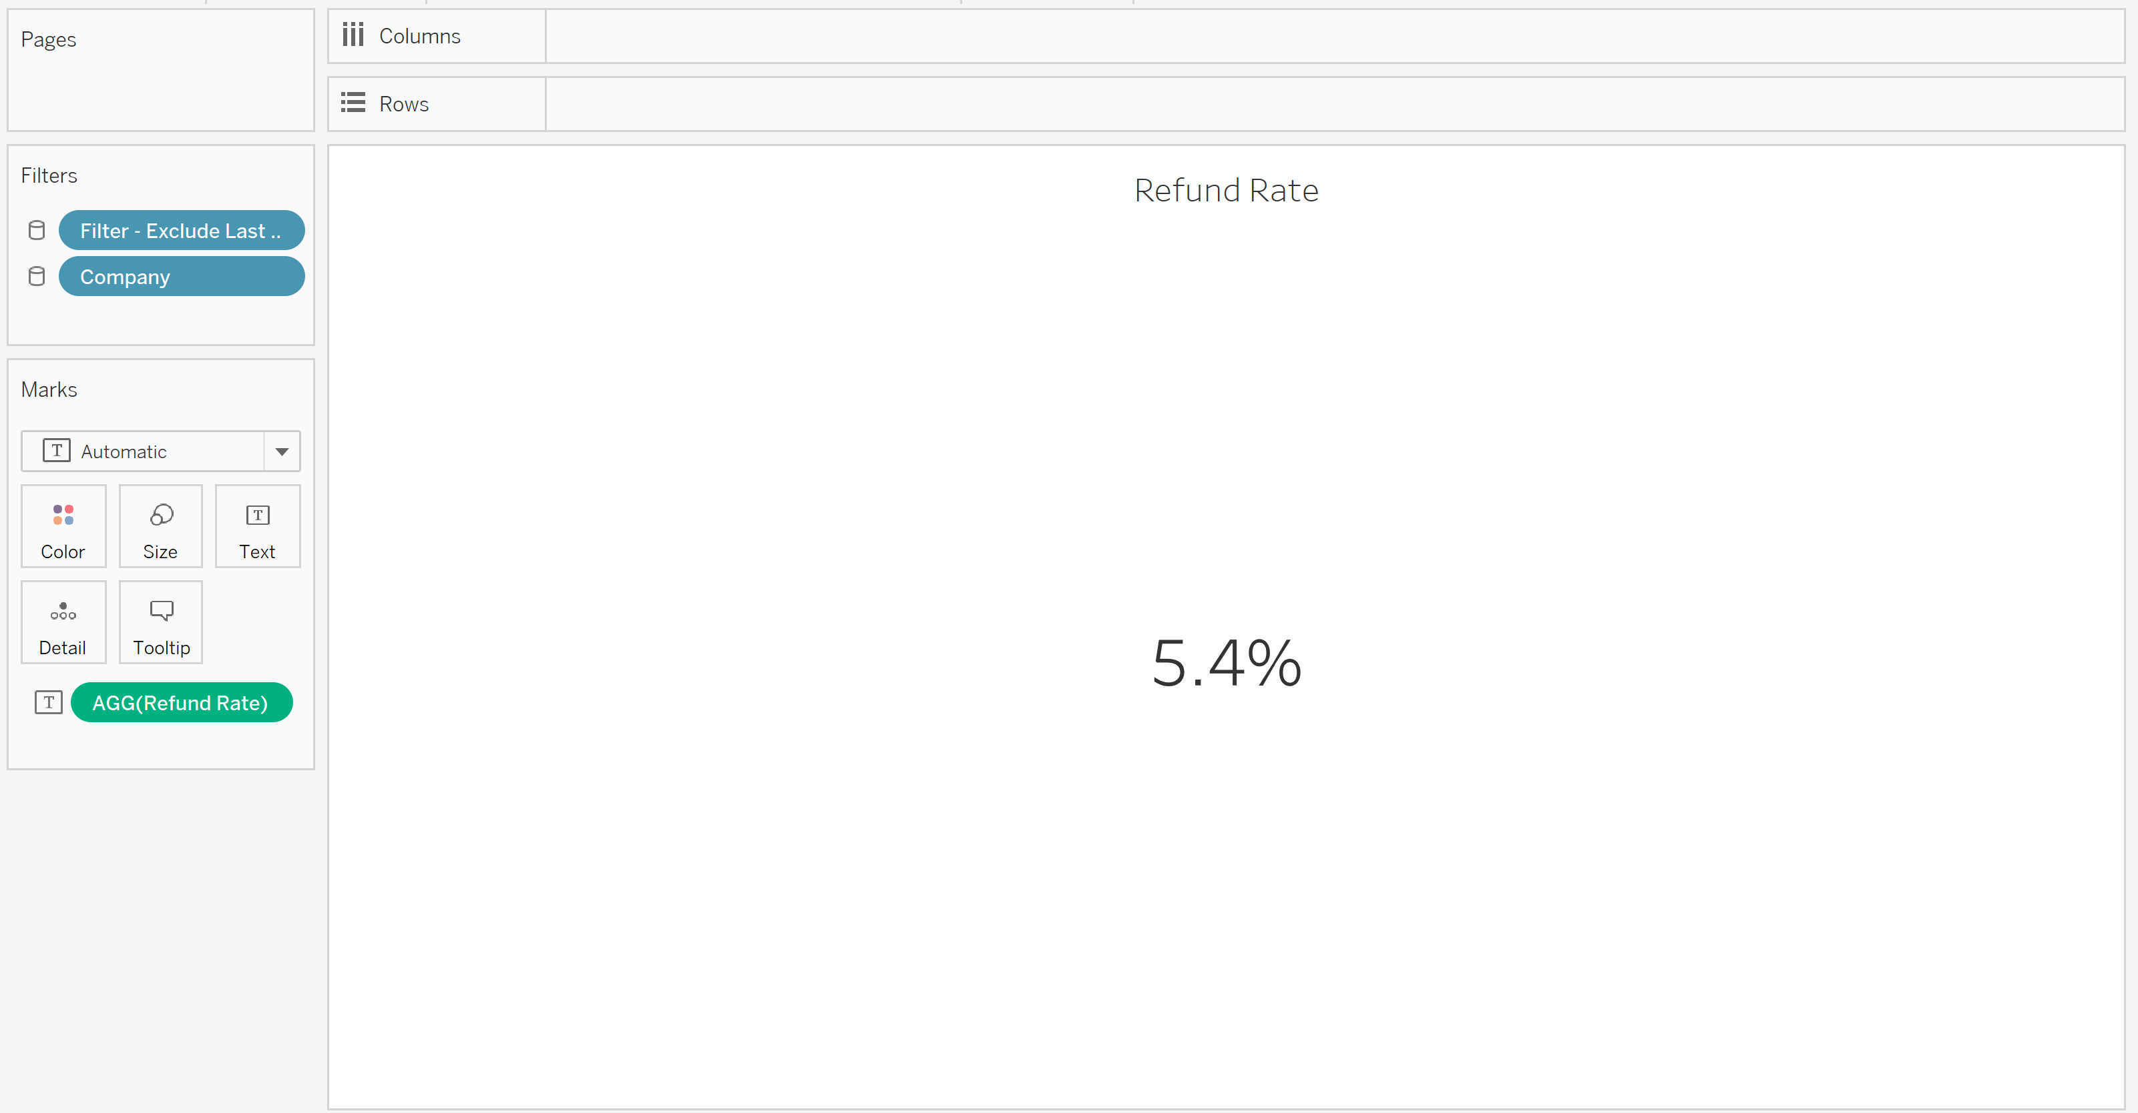

Break out Session 2

* 1. Line Chart
     1. Click a new sheet at bottom tabs of workbook that looks like a chart and plus
     2. Right click new sheet tab 🡪 Rename 🡪 Type Refund Rate Line Chart
     3. Drag Date dimension into the Columns shelf 🡪 Click on YEAR(Date) 🡪 Select second Month option 🡪 Date dimension should now be green indicating
     4. Drag Refund Rate into Rows shelf 🡪 Drag max – Refund Rate into Rows shelf next to Refund Rate 🡪 Click Max – Refund Rate 🡪 Dual Axis 🡪 Select Max – Refund Rate dropdown in Marks card 🡪 Update Automatic dropdown to circle 🡪 Click Size in Marks card 🡪 Move slider indicator between first and second tick marks on slider 🡪 Select Color in Marks card 🡪 Edit Colors 🡪 Click max – Refund Rate 🡪 Choose red 🡪 Select Refund Rate 🡪 Choose blue 🡪
     5. Right click secondary y-axis 🡪 Synchronize axis 🡪 Uncheck show header
     6. Right click null indicator in bottom right of view 🡪 Hide indicator
     7. Right click y-axis 🡪 Edit Axis 🡪 Uncheck Include zero 🡪 Edit Axis 🡪 Delete Title from Title in Axis Titles Section 🡪 Delete text 🡪 close window
     8. Right click y-axis 🡪 Format 🡪 Select Numbers in Scale section of Axis pane 🡪 Percentage 🡪 0 Decimal places 🡪Select Format Borders in buttons at top of format 🡪 Select Pane: in Row Divider section 🡪 None 🡪 Select Pane: in Column Divider section 🡪 None 🡪 Select Format Lines button at top of format 🡪 Select Rows tab 🡪 Select Grid Lines: in Lines Section 🡪 None
     9. Right click x-axis 🡪 Format 🡪 Select Dates dropdown in Scale section 🡪 Custom 🡪 Enter Mmm ‘YY (this will create a short date that’s easy to read) 🡪 Right click x-axis again 🡪 Edit Axis 🡪 Delete Title from Title in Axis Titles Section 🡪 Delete text 🡪 close window
     10. Format Title 🡪 Right click title 🡪 Edit Title to open dialog box 🡪 Delete all text 🡪 Type Refund Rate by Month and Year 🡪 OK

*When your line chart is complete it should look similar to image below*

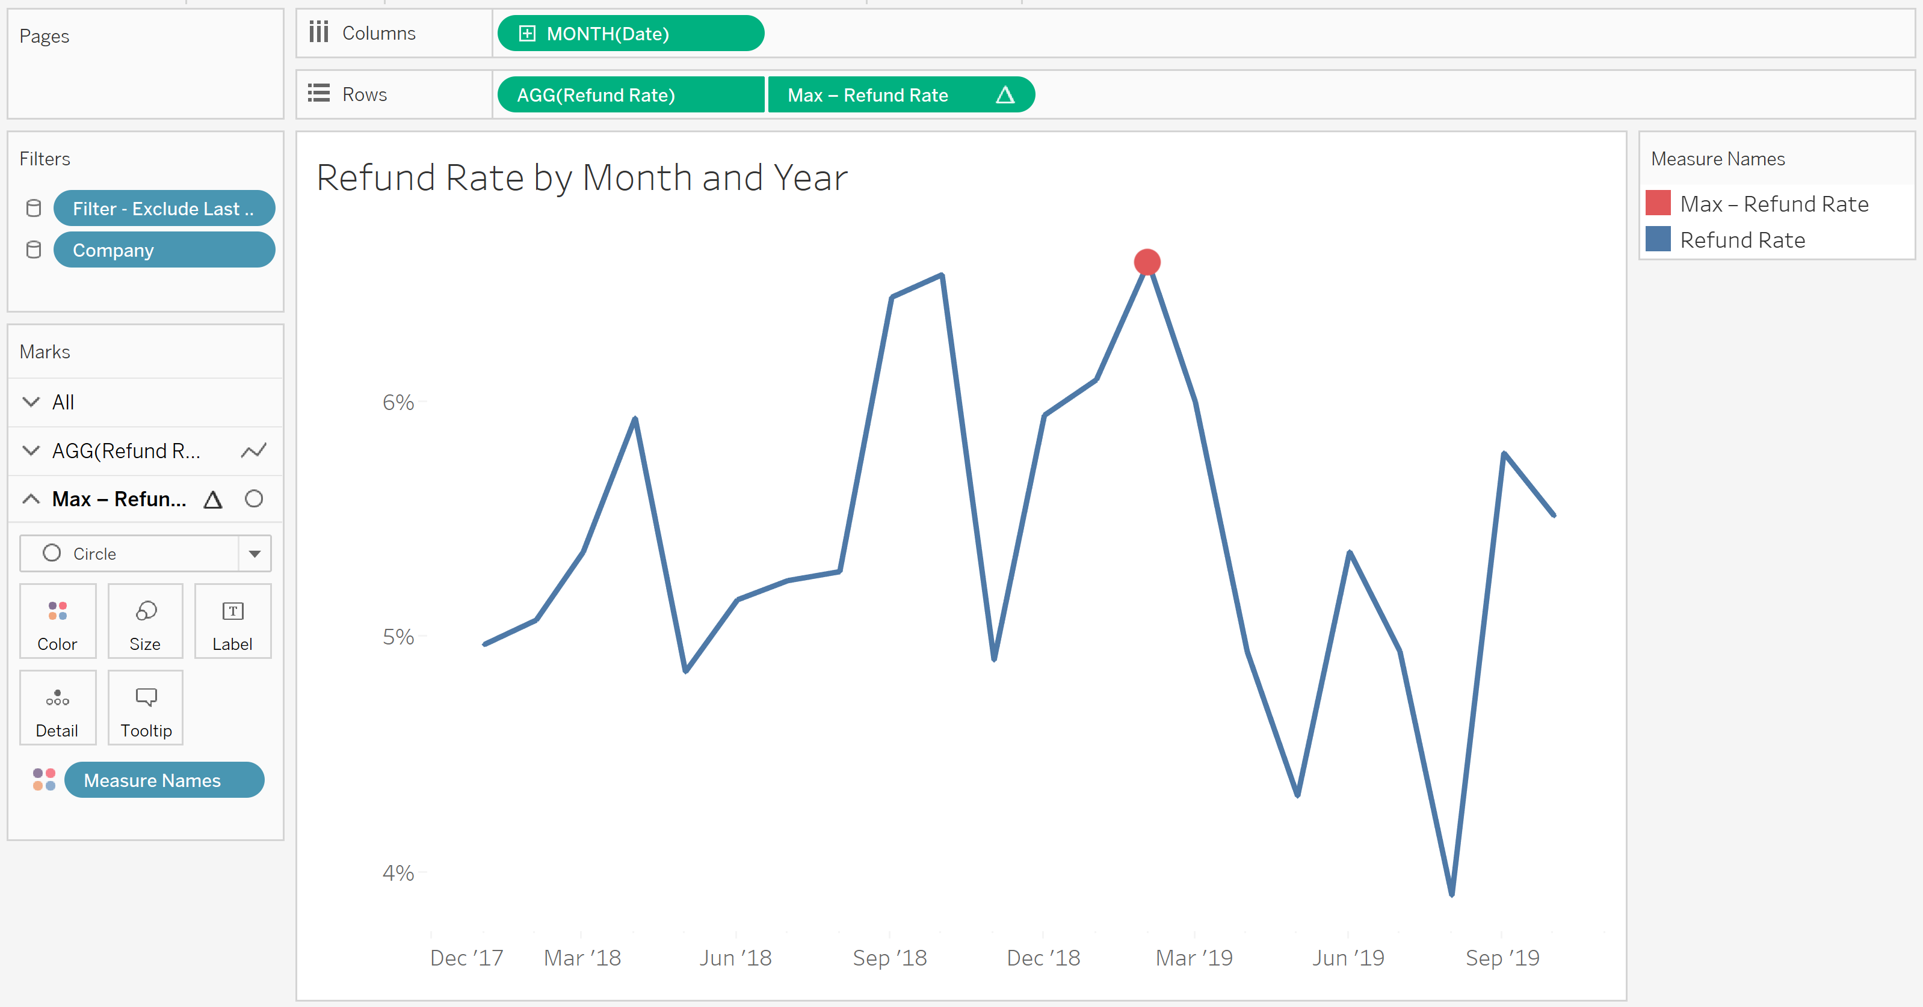

* 1. Bar charts
     1. Total Refunds Bar Chart
        1. Add a new worksheet 🡪 Click on the small icon to the right of the last sheet
        2. Rename sheet tab 🡪 right click Sheet tab at bottom of view 🡪 Type Total Refunds Bar Chart
        3. Columns: Drag Total Refunds into the columns shelf
        4. Rows: Drag Product dimension into rows shelf
        5. Sort: Select sort icon next to axis header to sort descending by complaint volume
        6. Drag Total Refunds to Label in Marks card
        7. Format Title 🡪 Right click title 🡪 Edit Title to open dialog box 🡪 Delete all text 🡪 Type Total Refunds by Product 🡪 OK
        8. Chart Formatting
           1. Right click x axis 🡪 Uncheck show header
           2. Hide field labels for rows

Right click on product above y-axis and select Hide Field Label for Rows

* + - * 1. Right click on y-axis 🡪 Format 🡪 Lines 🡪 Columns 🡪 Grid Lines 🡪 None 🡪 Axis Rulers 🡪 None
        2. Update aliases (Improves readability of y axis)

Right click on Product dimension in Data tab 🡪 Aliases… to open dialog box 🡪 Click each Value(Alias) and update to terms below

Checking or savings account --> Bank accounts

Credit card or prepaid card --> Credit cards

Credit reporting, credit repair services, or other personal consumer reports --> Credit reporting

Debt collection --> Debt collection

Money transfer, virtual currency, or money service --> Money transfer

Mortgage --> Mortgage

Payday loan, virtual currency, or money service --> Personal loan

Student loan --> Student loan

Vehicle loan or lease --> Vehicle loan

*When your bar chart is complete it should look similar to image below*

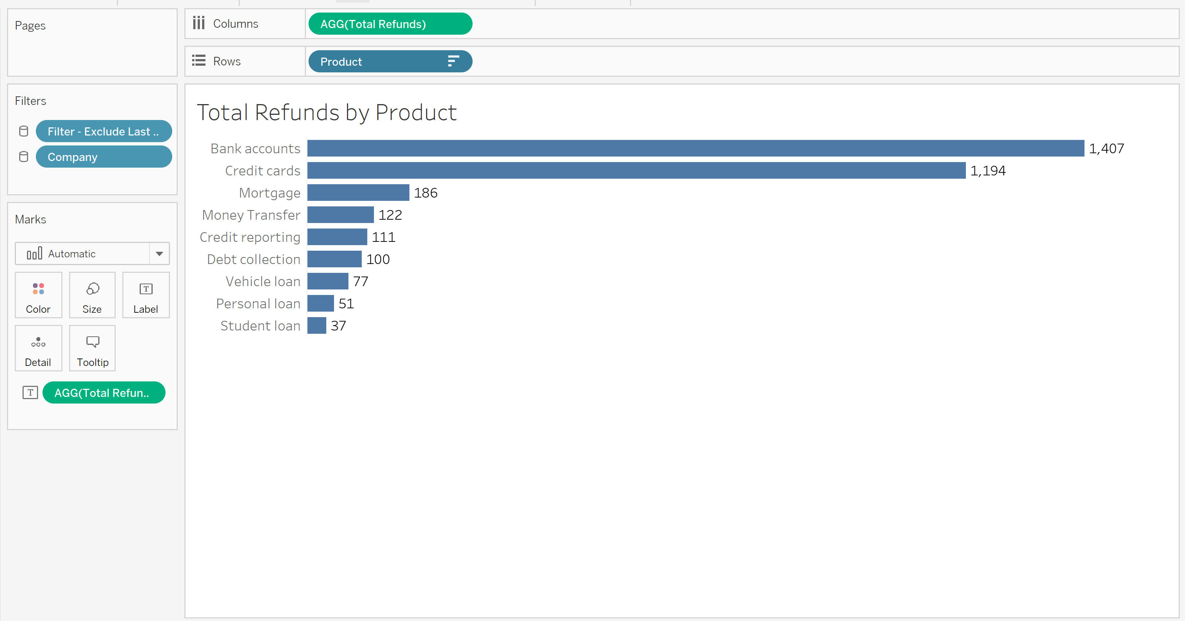

* + 1. Cleveland dot plot
       1. Add a new worksheet 🡪 Click on the small icon to the right of the last sheet
       2. Rename sheet tab 🡪 right click Sheet tab at bottom of view 🡪 Type Refund Rate Dot Plot
       3. Columns: Drag Window Max - Refund Rate measure to columns shelf.
       4. Rows: Drag Product dimension into the Rows shelf
          1. To create lines of Cleveland Dot Plot 🡪 Click Window Max pill in columns shelf 🡪 Compute Using 🡪 Product 🡪 Click chart type dropdown in Marks card 🡪 Bar 🡪 Size 🡪 Drag slider to left end for smallest bar width 🡪 Change color in Marks card to gray
          2. To create dots of Cleveland Dot Plot 🡪 Drag Refund Rate to columns shelf next to Window Max measure 🡪 Click measure 🡪 Dual Axis 🡪 click chart type dropdown in Marks card 🡪 circle 🡪 click Size in Marks card 🡪 Drag slider to middle tick mark 🡪 click Label in Marks card 🡪 Select Show mark labels 🡪 click Font dropdown 🡪 change font size to 6 in size dropdown 🡪 click Bold button to the left of size dropdown 🡪 Alignment middle 🡪 Change font color to white
          3. Right click top axis 🡪 Synchronize axis
          4. Format label value 🡪 Click Refund Rate in columns shelf 🡪 Format 🡪 Select Numbers in Default section of Pane tab 🡪 Percentage 🡪 0 decimal places
       5. Format Title 🡪 Right click title 🡪 Edit Title to open dialog box 🡪 Delete all text 🡪 Type Refund Rate by Product 🡪 OK
       6. Chart Formatting
          1. Right click product header of Cleveland dot chart --> Hide field labels for rows
          2. Right click on the bottom axis 🡪 Uncheck Show Header
          3. Right click in whitespace of Cleveland dot chart 🡪 Format 🡪 Borders 🡪 Sheet 🡪 Row Divider Pane 🡪 None 🡪 Column Divider Pane 🡪 None 🡪 Lines 🡪 Columns 🡪 Grid Lines 🡪 None 🡪 Zero Lines 🡪 None*When your dot plot is complete it should look similar to image below*

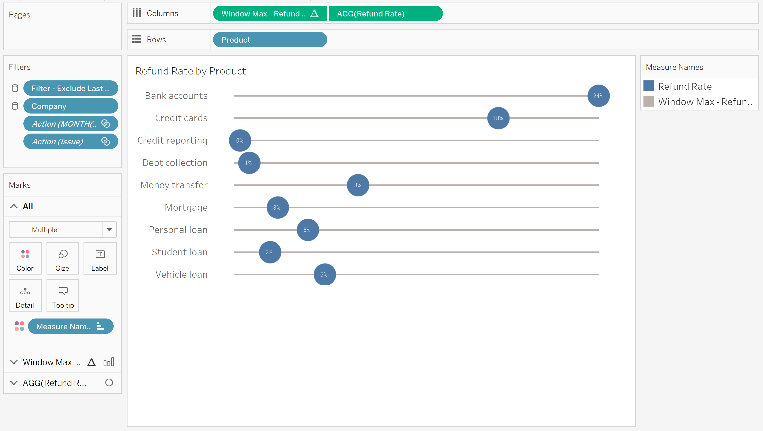

* + 1. Refund Rate Jitter Plot
       1. Add a new worksheet 🡪 Click on the small icon to the right of the last sheet
       2. Rename sheet tab 🡪 right click Sheet tab at bottom of view 🡪 Refund Rate Jitter Plot
       3. Columns: Right click in columns shelf whitespace 🡪 New Calculation 🡪 Type INDEX()
       4. Rows: Drag Refund Rate measure to Rows shelf
       5. Update chart to Jitter Plot with following steps
          1. Drag Issue dimension into Detail in Marks card
          2. Click INDEX() measure in columns shelf 🡪 Compute Using 🡪 Issue
          3. Click chart type dropdown in Marks card 🡪 Select circle
          4. Drag Total Refunds measure into Size in Marks card 🡪 Select Size in Marks Card 🡪 Drag slider between first and second tick marks
          5. Select color in marks card 🡪 Under Opacity change 100% to 50%
       6. Format Title 🡪 Right click title 🡪 Edit Title to open dialog box 🡪 Delete all text 🡪 Type Refund Volume and Rate by Issues 🡪 OK
       7. Chart formatting
          1. Right click y axis 🡪 Format 🡪 Axis 🡪 Numbers 🡪 Percentage 🡪 0 decimal places
          2. Right click y axis 🡪 Edit axis 🡪 Title 🡪 Delete Title 🡪 close window [x]
          3. Right click x axis 🡪 unclick show header
          4. Right click in graph whitespce 🡪 Format 🡪 Lines 🡪 Sheet 🡪 Grid Line 🡪 None 🡪 Rows 🡪 Zero Lines 🡪 None 🡪 Columns 🡪 Axis Rulers 🡪 None

*When jitter plot is complete it should look similar to image below*

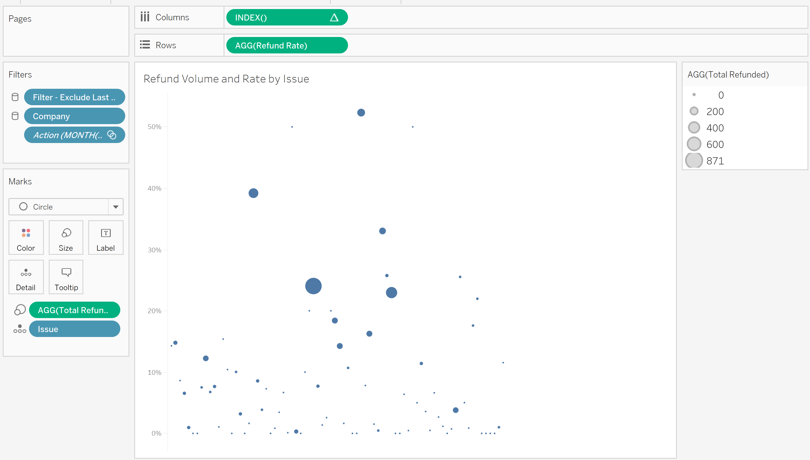

1. Creating Dashboards

*You will resize dashboard area to automatic so when published it fits audience’s screen resolution*

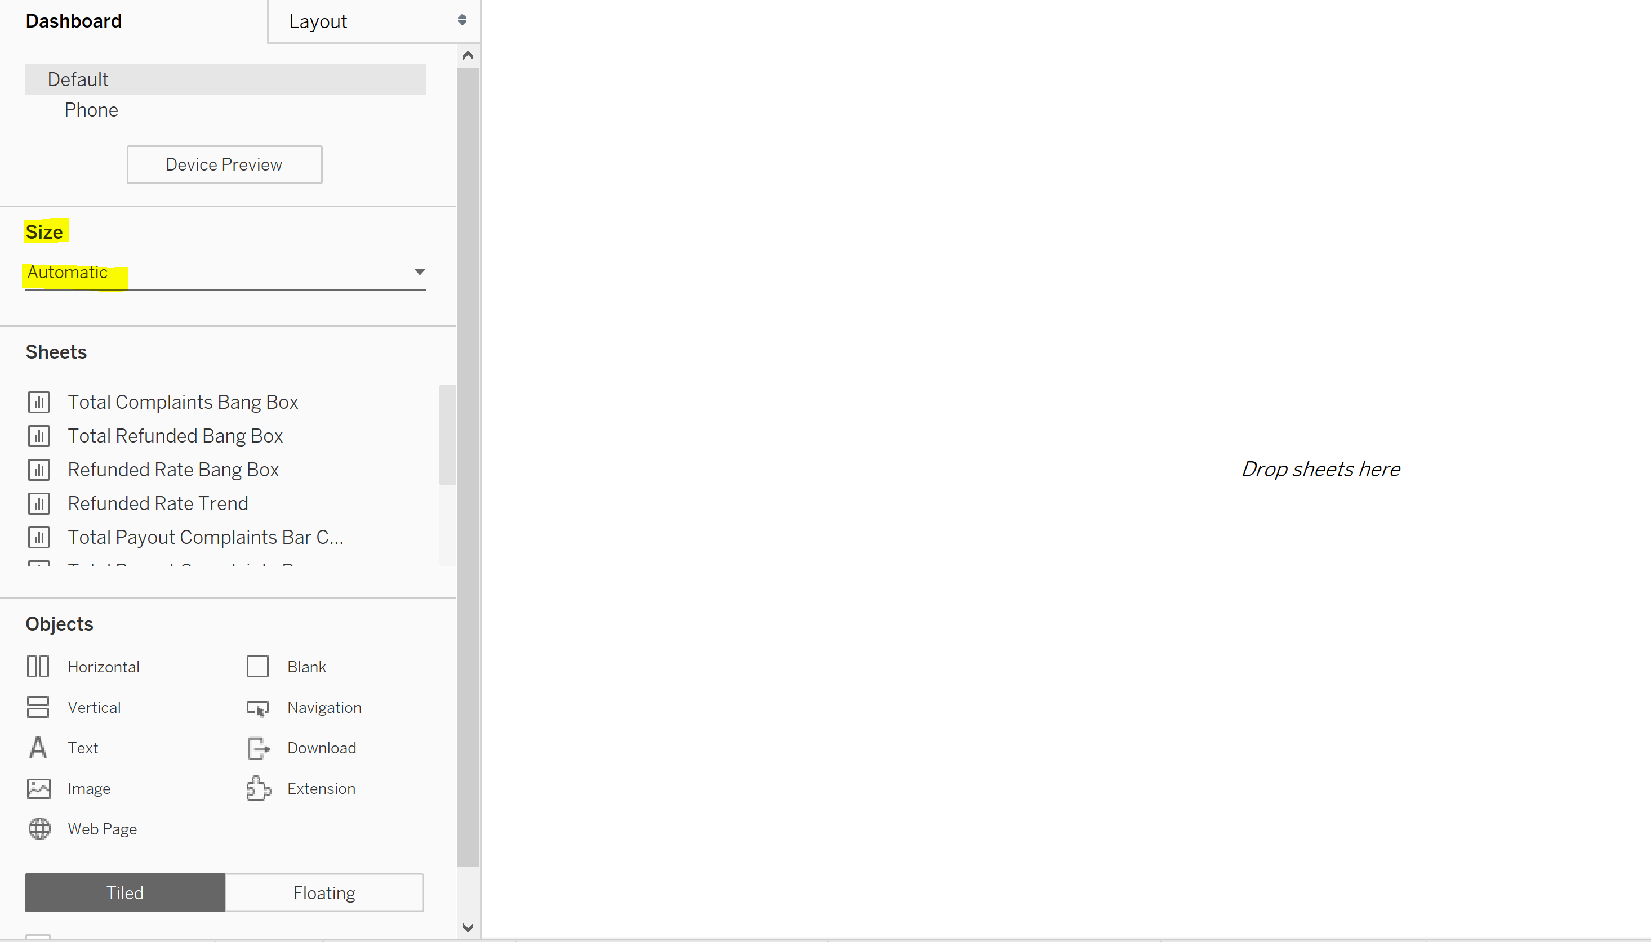

* 1. Create a new dashboard 🡪 Click on the second small icon to the right of the last sheet (looks like a crosshair)
  2. Rename dashboard tab 🡪 Right click dashboard tab at bottom of view area 🡪 Rename 🡪 Type Refund Rate Dashboard
  3. Resize the dashboard 🡪 Size in Dashboard pane 🡪 Update size by clicking min/max dropdown 🡪 Change range to Automatic

*For the next few steps, you will use Dashboard tab to drag in sheets and objects into dashboard view*

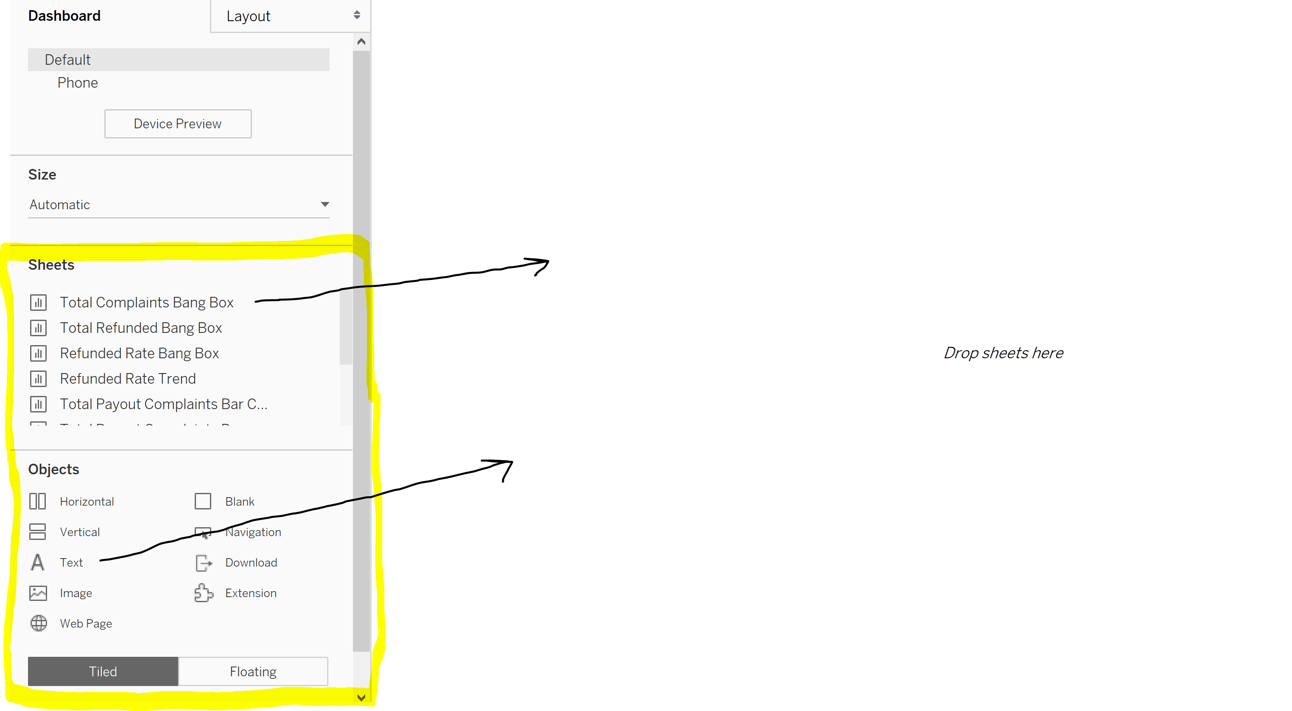

*And the Layout tab is where you’ll resize and position the sheets you drag into the view*

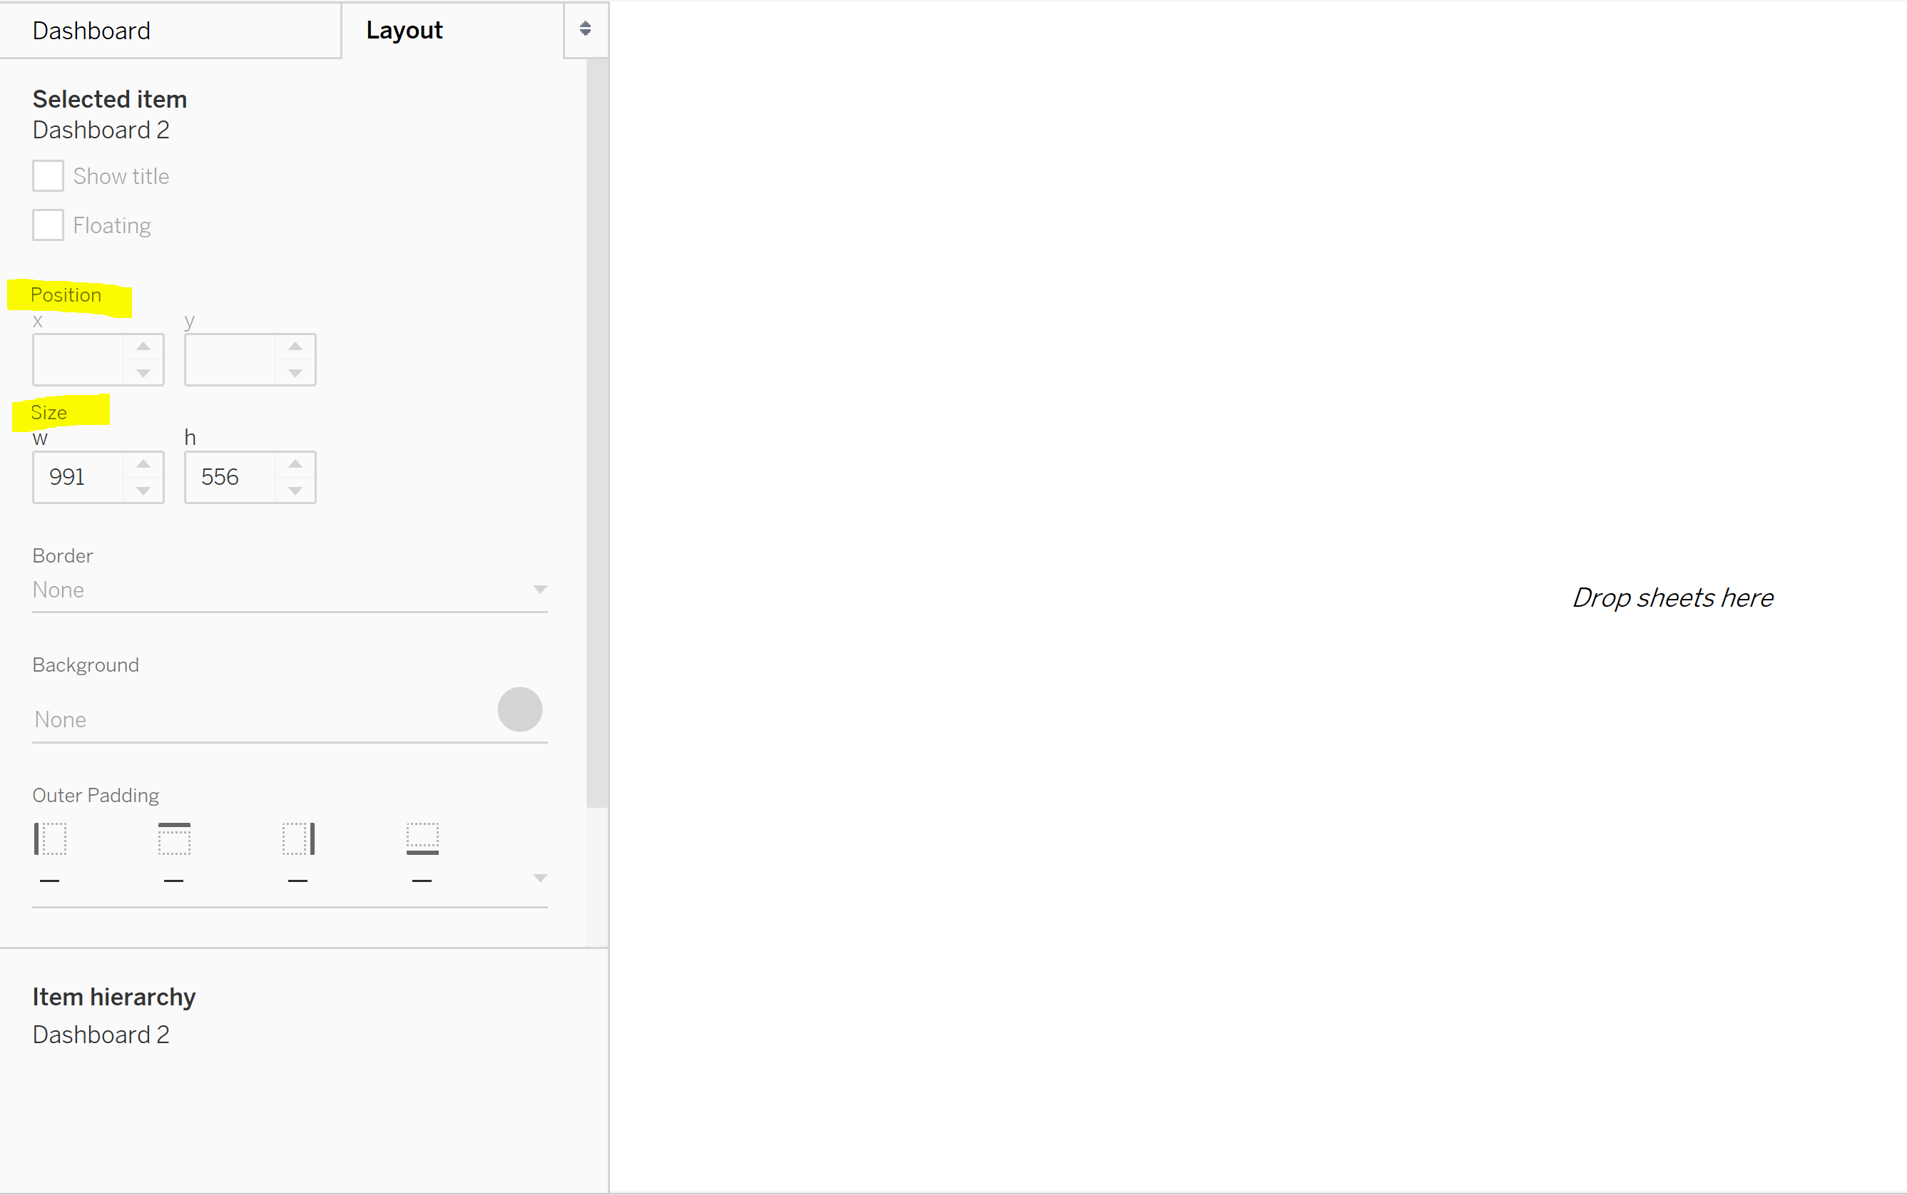

* 1. Add a title to your dashboard
     1. Select the floating option in the Objects section of the Dashboard pane 🡪 Drag a Text object into the View area to open a dialog box 🡪 Type Refund Rate Dashboard 🡪 Highlight text 🡪 Increase font size by 16 in font size dropdown 🡪 Change text color to dark blue 🡪 OK 🡪 Select the Background in Layout tab 🡪 Light blue
     2. Update the size and the location of the Text object
        1. Select the Layout pane 🡪 Select the Text object 🡪 Update size in the Layout pane in the Selected Items section 🡪 Change width (w) to 1060 🡪 Change height (h) to 50 🡪 Update position 🡪 Change x to 0 🡪 Change y to 0

*Your dashboard should look similar to this after adding title*

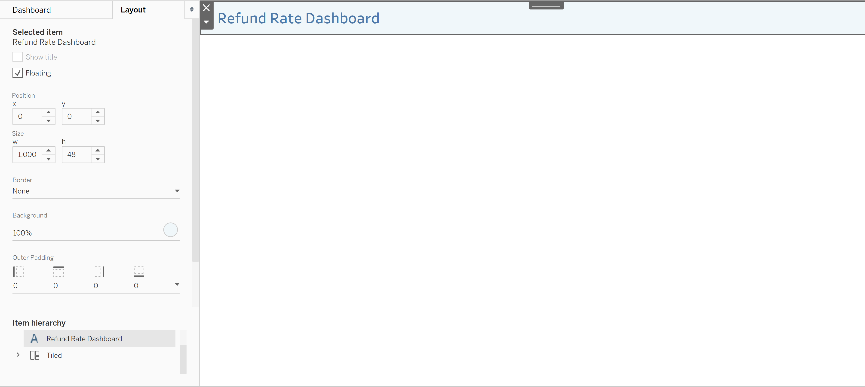

*Now you will use containers for your bang boxes to help with positioning and alignment*

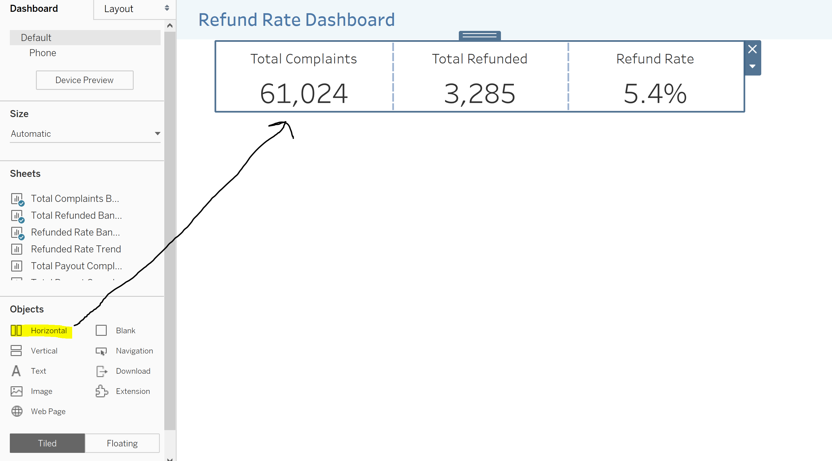

* 1. Add the bang boxes to the dashboard view
     1. Drag a horizontal container from Objects section of Dashboard pane🡪 Resize the object to w = 625 and h = 115 🡪 Reposition the containers to x = 50 and y = 70
     2. Select the Tiled Object option 🡪 drag each bang box individually into the container to the left of each box.

*The rest of the Sheets objects can be dragged to any position, then resize and position per directions*

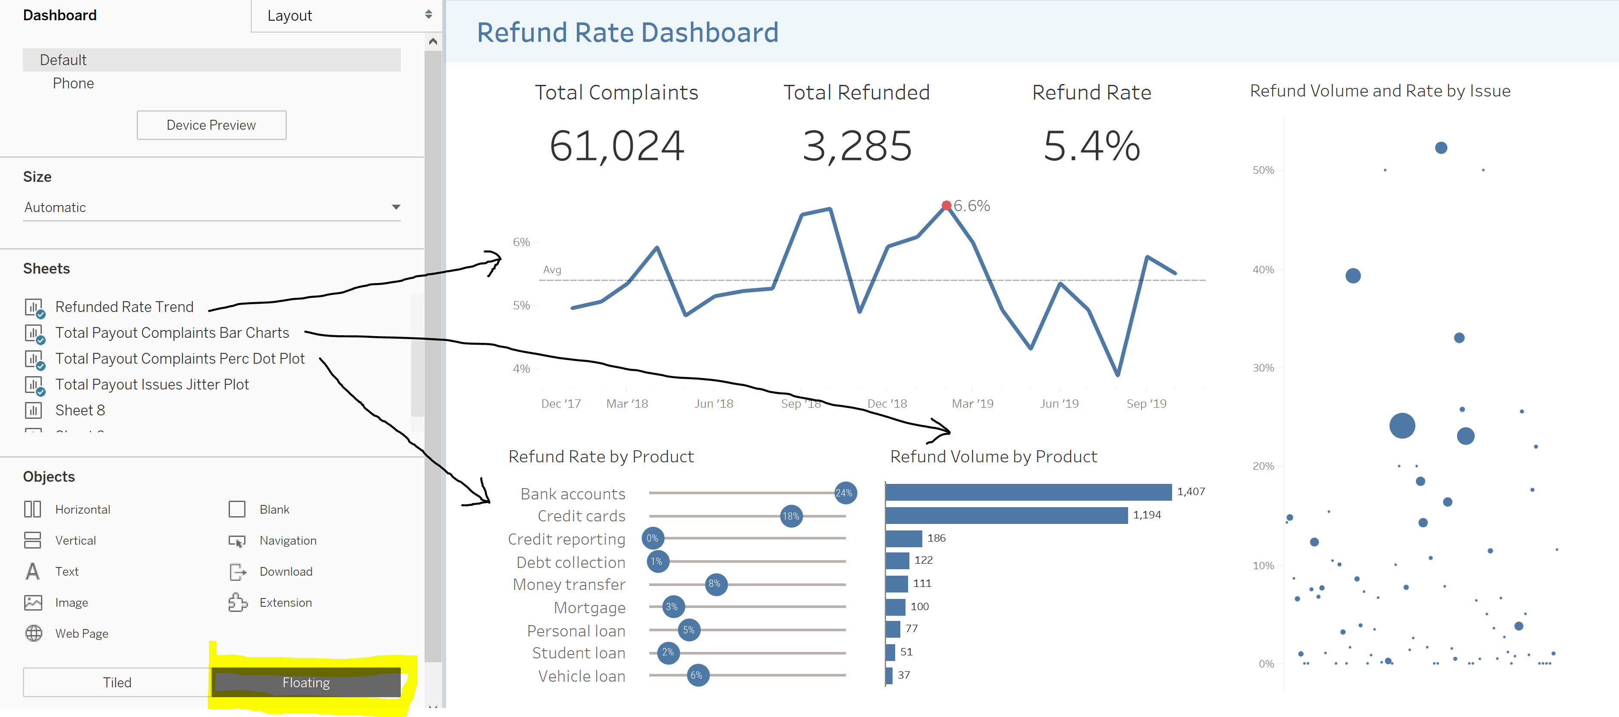

* 1. Add the line chart
     1. Drag the line chart into the dashboard view 🡪 Select the line chart in dashboard view 🡪 Resize to w = 540 and h = 172 🡪 Reposition to x = 50 and y = 151 🡪 Click box 🡪 Click white down arrow 🡪 Fit 🡪 Entire View
  2. Add the dot plot
     1. Drag the dot plot into the dashboard view 🡪 Select the dot plot in dashboard view 🡪 Resize to w = 280 and h = 192 🡪 Reposition to x = 46 and y = 341 🡪 Click box 🡪 Click white down arrow 🡪 Fit 🡪 Entire View
  3. Add the bar chart
     1. Drag the bar chart into the dashboard view 🡪 Select the bar chart in dashboard view 🡪 Resize to w = 262 and h = 192 🡪 Reposition to x = 341 and y = 341 🡪 Click box 🡪 Click white down arrow 🡪 Fit 🡪 Entire View
  4. Add the scatterplot
     1. Drag the scatterplot into the dashboard view 🡪 Select the scatterplot in dashboard view 🡪 Resize to w = 254 and h = 478 🡪 Reposition to x = 619 and y = 58 🡪 Click box 🡪 Click white down arrow 🡪 Fit 🡪 Entire View
  5. Update all header titles sizes at once
     1. Select Dashboard in menu pane 🡪 Format 🡪 Worksheet Titles 🡪 Update to 12pt

*After dragging in all containers, your dashboard should look similar to image below*

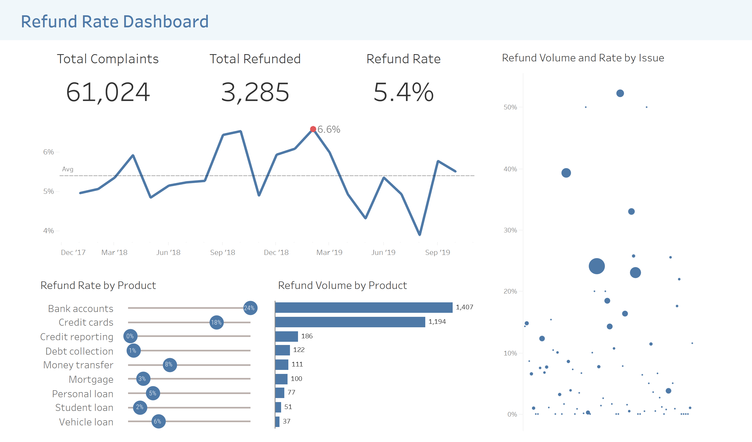

*Now that you finished the design, add some actions to dashboard for user interactivity*

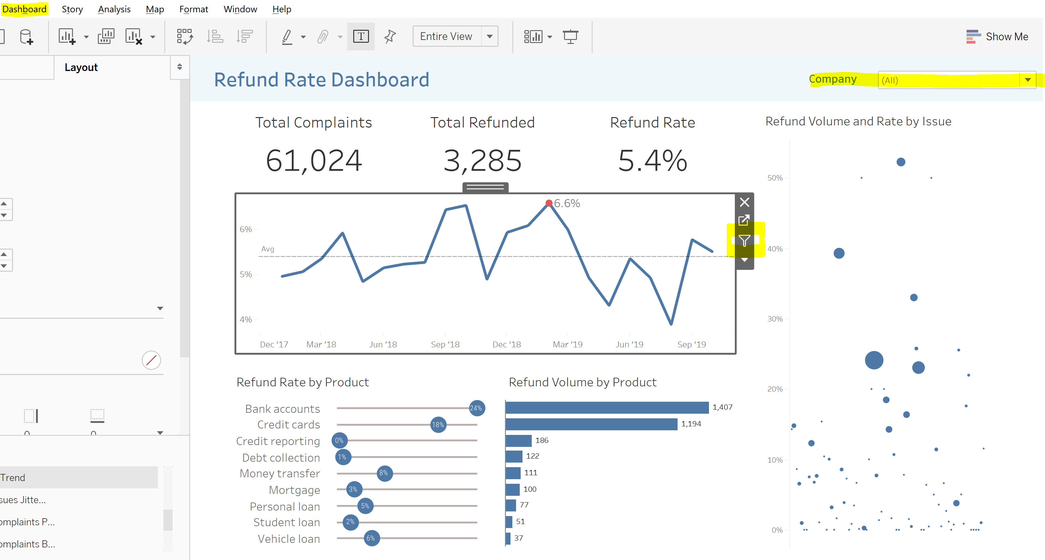

1. [Extra Credit] Add some actions to your dashboard for dashboard interactivity
   1. There are three options to create action filters on a dashboard
   2. Add a filter from one of your sheets (since you applied filters to all using data source it will filter all visuals)
      1. Click the line graph 🡪 a menu will appear on the left of line graph 🡪 Select the white down arrow 🡪 Select Filters 🡪 Company
         1. Select the filter 🡪 Select the white drop down arrow 🡪 Select Single Value (dropdown) 🡪 Resize in the Size section of the Layout tab to w = 250 and h = 25 🡪 Reposition to x = 370 and y = 15
   3. You can use an object filter to filter other objects
      1. Click the line chart 🡪 a menu will appear on the left of line graph 🡪 Select the white filter icon in the menu pane.
         1. After selecting the white filter icon, you can select any month in the line graph and see how the other update when selected
   4. Finally, Actions in the Dashboard menu at the top allows you to make objects interact with one another
      1. Click the Dashboard menu button 🡪 Select Actions which opens a dialog box 🡪 Click the Add Action > button 🡪 Rename the filter action to Box and Line Filter 🡪 Filter 🡪 In the Source Sheets section, Uncheck all sheets except for the Jitter Plot 🡪 In the Target Sheets section, Uncheck all sheets except the three bang boxes and the line chart 🡪 OK 🡪 OK
         1. When you select a dot in the jitter plot, then the bang boxes and line chart is filtered while the dot plot and bar charts stay the same
2. Publish your report to the web
   1. Select Save to Public by selecting disk icon in the top taskbar 🡪 Name it Product Complaints Payout Dashboard 🡪 Click Save to publish it to Tableau Public
3. Congratulations!!! You have published a Tableau Dashboard to Tableau Public. Now you can share your work with others.

